理工学院创新作坊Workshop报名

SSE Maker Lab Workshop Recruitment

理工学院创新作坊Workshop又来了！创新作坊是一个可以充分发挥自己想象力和动手能力的空间，配有专业设备，包括智能车、无人机、激光切割机，3D打印、热像仪、铣床加工等设备。本次Workshop将为大家介绍Linux系统和树莓派的使用，并搭配一些有趣的小实验。本次活动无需预备知识，面向大一学生，欢迎感兴趣的同学快来报名参加吧！

SSE Maker Lab workshop is coming! Maker Lab is a space where you can give full play to your imagination and hands-on ability. Now it is equipped with equipment such as smart cars, drones, and laser cutting machine, 3D printing, thermal imager, milling machine processing and other equipment. This workshop will introduce the use of Linux system and Raspberry Pi, with some interesting small experiments. This workshop targets for freshman students and requires no preparatory knowledge. Come and play together.

* **Workshop内容Workshop Content**

**1.Linux操作系统介绍Introduction to Linux Operating System**

Linux是一种免费使用和自由传播的操作系统，由于其开源性，强大的网络功能等优点而被广泛使用。本次Workshop将为大家介绍Linux的一些基础知识和基本指令，并通过一些练习带领你亲自使用Linux。

Linux is a free-to-use and freely disseminated operating system, which is widely used due to its advantages such as open source and powerful network functions. This workshop will introduce some basic knowledge and basic instructions of Linux, and guide you to use the Linux system personally through some exercises.

**2.树莓派介绍Introduction to Raspberry Pi**

树莓派是一款基于ARM的微型电脑主板，它外形只有信用卡大小，却具有电脑的所有基本功能。本次Workshop将领大家动手操作树莓派，并设计了几个小实验帮助大家熟悉树莓派的使用。Maker Lab为大家提供树莓派3B+，4B等型号。

The Raspberry Pi is an ARM-based microcomputer motherboard of the size of a credit card, but has all the basic functions of a computer. This workshop will guide you to operate the Raspberry Pi by several small experiments. Maker Lab provides Raspberry Pi 3B+ and 4B.

1. **网络通信的基本概念**

网络通信是信息产业的基础。TCP/IP协议栈是当前最广泛使用的网络通信技术，用于互联网、蜂窝无线通信网络中。本次workshop将为大家讲解网络通信中常用的基本概念，并通过简单的socket programming来帮助大家了解TCP 和UDP两种端到端通信协议。

Network communication is the foundation among the information technologies. TCP/IP protocol stack is the most widely used network communication technology, used in the Internet and cellular wireless communication networks. This workshop will explain the basic concepts network communication and help you understand TCP and UDP through simple socket programming.

* **日程Schedule**

暂定日程：3场研讨会，2023年2月下旬 - 3月上旬

Tentative schedule: 3 Workshops, Mid February-- Mid March.

**Workshop 1:**

* 学习如何使用树莓派
* 学习Linux常用指令
* 在TA的帮助下，自己上手通过PC端连接树莓派
* 在树莓派上练习Linux 命令，完成小任务

**Workshop 2:**

* 学习并理解socket
* 学习两种通信协议(TCP/IP 和UDP)的基本原理
* 学习用Python实现简单的通信传输 (socket programming)
* 尝试更改信息吞吐率 Try to modify the transmission throughput

**Workshop 3:**

* 学习并尝试将Workshop2的代码上传到树莓派，实现PC端和树莓派的双向/单向通信
* Bonus question: 1)尝试在本机电脑实现进程与进程间的通信（unix domain socket）； 2）尝试对电脑与树莓派之间的通信进行测试评估（如测试速率，丢包，延迟等）
* **报名与联系方式Apply&Contact**

欢迎大家链接填写或者扫码报名参加本次Workshop，本次Workshop计划招收40名左右学员，先到先得，快来参加吧。

Link：<https://docs.qq.com/sheet/DVmVRWVVlbkZrdlJG?tab=BB08J2>

QR Code：



Welcome to fill in the link or scan the code to sign up for this workshop. This workshop plans to recruit about 40 students, first come first served, come and join us.

Link：<https://docs.qq.com/sheet/DVmVRWVVlbkZrdlJG?tab=BB08J2>

QR Code：



* 报名后请扫码进群Please scan the code to join the wetchat group after registration

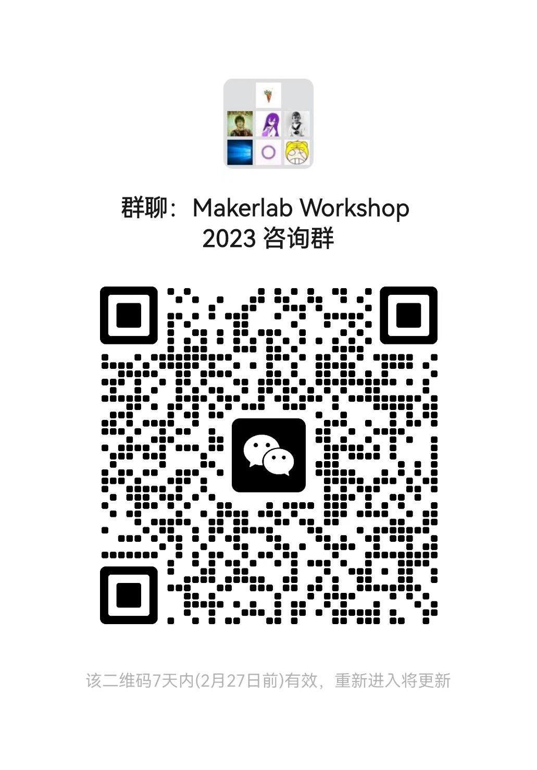

联系邮箱contact email：ricali@cuhk.edu.cn